Exercise 3-5 Lavent Vector Comparison

Jirayu Petchhan, D10907801

**VGG16 model**

Coding

Using VGG16 model

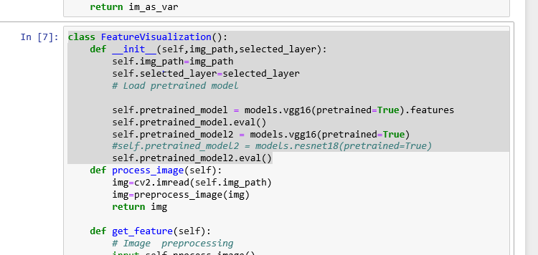

Whole image

|  |  |
| --- | --- |
| C:\Users\e_user\AppData\Local\Microsoft\Windows\INetCache\Content.Word\p.jpg | C:\Users\e_user\AppData\Local\Microsoft\Windows\INetCache\Content.Word\pc.jpg |
| p.jpg (1 class) | pc.jpg (2 classes) |

Bounding box

|  |  |
| --- | --- |
| C:\Users\e_user\AppData\Local\Microsoft\Windows\INetCache\Content.Word\p2.jpg |  |
| P2.jpg | Pc2.jpg |

Different locations

|  |  |
| --- | --- |
|  |  |
| P1.jpg | Pc1.jpg |

VGG16 Model

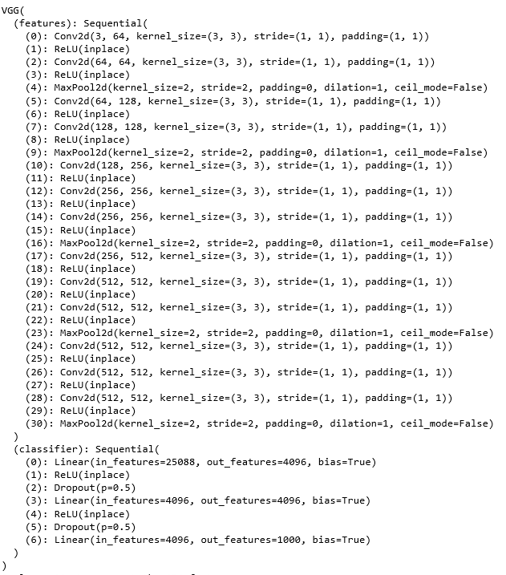

Result

Whole picture

|  |  |
| --- | --- |
| p.jpg | pc.jpg |
|  |  |
| Top1 predicted to pug (88.57 %) | Top1 predicted to paper towel (26.99 %) |

Different locations

|  |  |
| --- | --- |
| P1.jpg | Pc1jpg |
|  |  |
| Top1 predicted to pug (57.65 %) | Top1 predicted to nipple (6.73 %) |

Bounding Box

|  |  |
| --- | --- |
| P2.jpg | Pc2.jpg |
|  |  |
| Top1 predicted to cleaver (4.91 %) | Top1 predicted to spatula (8.19 %) |

Lavent vector comparison (Cosine Similarity)

|  |  |
| --- | --- |
| Whole picture | Cosine Similarity equals 0.7097 |
| Different locations | Cosine Similarity equals 0.7020 |
| Bounding Box | Cosine Similarity equals 0.8216 |

Whole picture

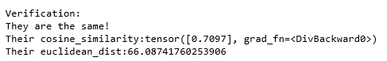

Different locations

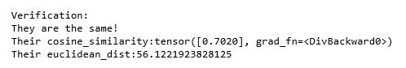

Bounding Box

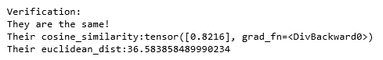

**ResNet18 model**

Coding

Using ResNet18 model

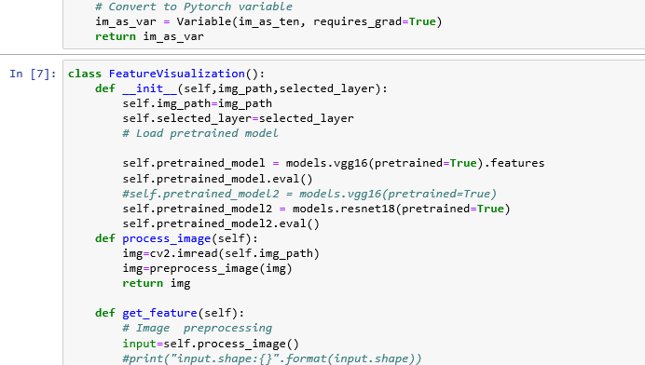

Still using p and pc.jpg the same

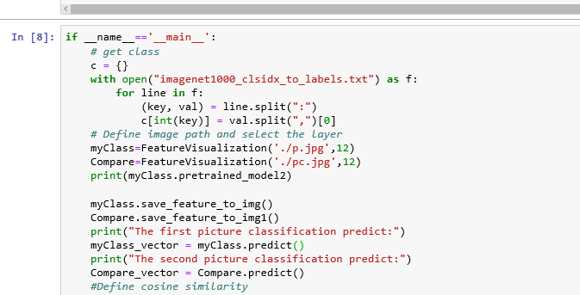

Pictures

Whole image

|  |  |
| --- | --- |
| C:\Users\e_user\AppData\Local\Microsoft\Windows\INetCache\Content.Word\p.jpg | C:\Users\e_user\AppData\Local\Microsoft\Windows\INetCache\Content.Word\pc.jpg |
| p.jpg (1 class) | pc.jpg (2 classes) |

Bounding box

|  |  |
| --- | --- |
| C:\Users\e_user\AppData\Local\Microsoft\Windows\INetCache\Content.Word\p2.jpg | C:\Users\e_user\AppData\Local\Microsoft\Windows\INetCache\Content.Word\pc2.jpg |
| P2.jpg | Pc2.jpg |

Different locations

|  |  |
| --- | --- |
| C:\Users\e_user\AppData\Local\Microsoft\Windows\INetCache\Content.Word\p1.jpg | C:\Users\e_user\AppData\Local\Microsoft\Windows\INetCache\Content.Word\pc1.jpg |
| P1.jpg | Pc1.jpg |

ResNet 18 Model

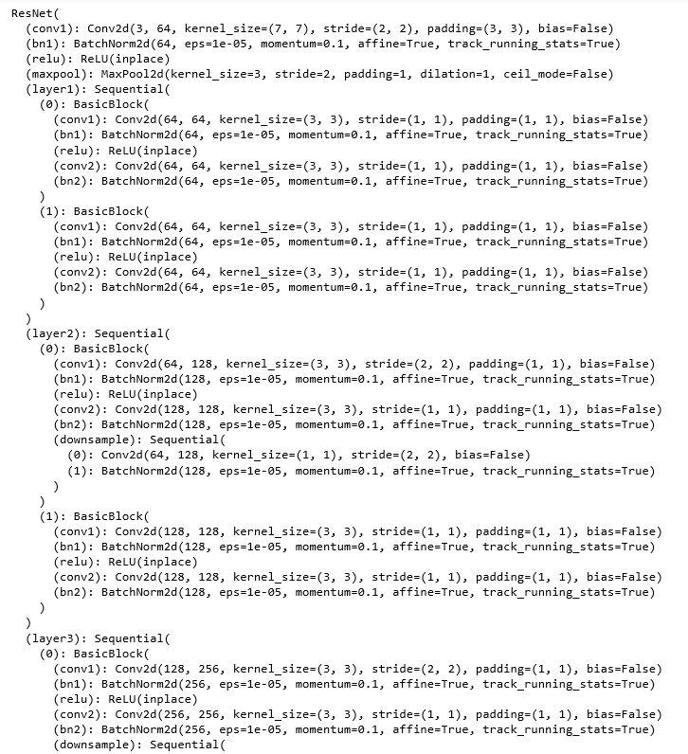

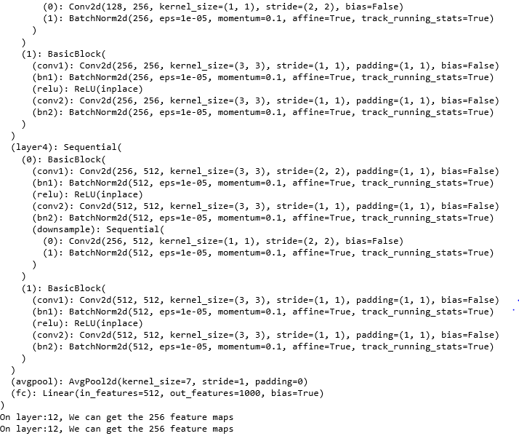

Result

Whole picture

|  |  |
| --- | --- |
| p.jpg | pc.jpg |
|  |  |
| Top1 predicted to pug (41.88 %) | Top1 predicted to paper towel (16.06 %) |

Different locations

|  |  |
| --- | --- |
| P1.jpg | Pc1jpg |
|  |  |
| Top1 predicted to pug (80.39 %) | Top1 predicted to nipple (8.47 %) |

Bounding Box

|  |  |
| --- | --- |
| P2.jpg | Pc2.jpg |
|  |  |
| Top1 predicted to cleaver (5.91 %) | Top1 predicted to spatula (8.89 %) |

Lavent vector comparison (Cosine Similarity)

|  |  |
| --- | --- |
| Whole picture | Cosine Similarity equals 0.5796 |
| Different locations | Cosine Similarity equals 0.4689 |
| Bounding Box | Cosine Similarity equals 0.7806 |

Whole picture

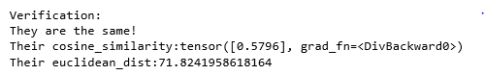

Different locations

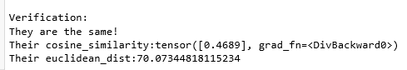

Bounding Box

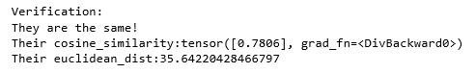

**Conclusion**

Cosine Similarity

|  |  |  |  |
| --- | --- | --- | --- |
|  | Whole picture | Different Locations | Bounding Box |
| VGG 16 | 0.7097 | 0.7020 | 0.8216 |
| ResNet 18 | 0.5796 | 0.4689 | 0.7806 |

We will see the Cosine Similarity results from Whole image, different locations and bounding box from training with VGG16 model is make a value of cosine similarity more than training with ResNet 18 Model.